Literacy support worksheet

3.1 Energy can be transferred

Pages 40-43 and 168

Energy transfers

1 What is an energy transfer?

2 In the diagram below, you can see the transfer of energy from one object to another.

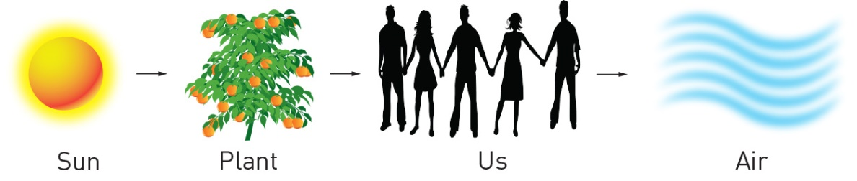

What is the name given to the transfer of energy from:

a the Sun to plants?

b plants to humans?

7 For each of the pictures below, label the type of energy present:

|  |  |  |  |
| --- | --- | --- | --- |
| SW0302_00951 | SW0303_00951 | SW0304_00951 | SW0305_00951 |
| SW0306_00951 | SW0307_00951 | SW0308_00951 | SW0309_00951 |
| SW0310_00951 | SW0311_00951 | SW0312_00951 | SW0313_00951 |

4 Draw a flowchart (the first one has been done for you using words only), similar to the diagrams on pages 40–43, for the transfer of:

a the Sun’s energy to an iPhone

Solar 🡪 electricity 🡪 chemical (battery) 🡪 electrical 🡪 heat/ light/ sound

b chemical energy in coal to a toaster

c tidal energy (which generates electricity using a turbine) to a television

d chemical energy (battery) to a car radio

e the Sun’s energy to a person bouncing a basketball

Word detective

5 Matching meaning

Draw a line to match each type of energy below (the words on the left) with its meaning (on the right):

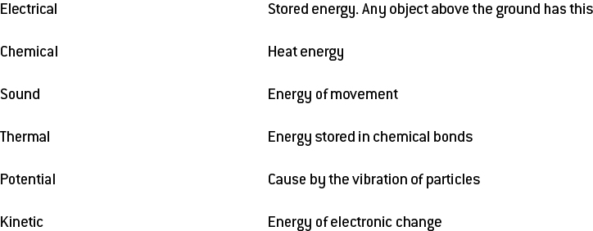

One type of energy is missing from this list. What is it?

Literacy support worksheet

3.2 Potential energy is stored energy

Pages 44–45 and 170

Potential energy is stored energy

1 What is potential energy?

2 What are the four types of potential energy? Give an example of each.

a

b

c

d

3 For each picture below, label the type of potential energy:

|  |  |  |  |  |
| --- | --- | --- | --- | --- |
| SW0617_01361 |  | SW0618_01361-rm |  | SW0619_01361-rm |
| SW0620_01361-rm |  | SW0621_01361-r |  | SW0622_01361-r |
| SW0623_01361-r |  | SW0624_01361-r |  | SW0612_01361-r |

4 Potential energy is used in children’s playgrounds. Choose five pieces of play equipment shown in the diagram below. For each item selected, name the type of equipment, the type of potential energy it uses and the movement that it makes. The first one has been done for you.

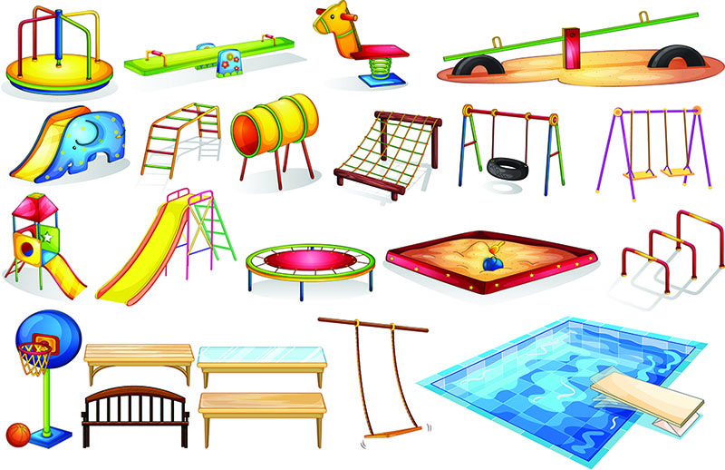

|  |  |  |
| --- | --- | --- |
| Equipment | Potential energy | Movement/Motion |
| a springboard | elastic potential energy | propels you up to jump into water |
| b |  |  |
| c |  |  |
| d |  |  |
| e |  |  |

Word detective

6 Secret message

Use words from the Student Book to work out the secret message below:

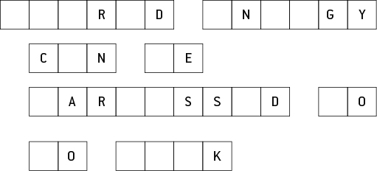

Literacy support worksheet

3.3 Moving objects have kinetic energy

Pages 46–47 and 171

Kinetic energy

1 What is kinetic energy?

2 Do larger objects or smaller objects have the greatest kinetic energy?

3 Give four examples of kinetic energy.

a

b

c

d

4 The larger the object the greater the kinetic energy. The faster the object, the greater the kinetic energy. Circle which object has greatest kinetic energy in each question.

a Jogger or Sprinter

b Car or Train (both going at 100kms/hour)

c Electricity or Flowing water

d Bicycle (5km/hr) or Motorcycle (60km/hr)

5 When we are talking about energy, what is work? Circle the correct answer.

a What we do at school

b Kinetic energy

c When a force moves an object

6 What is electrical energy?

7 What is hydroelectricity?

8 How is electrical power made in a hydroelectric power station?

9 How could an asteroid, only 15 kilometres wide, change the climate conditions on Earth?

10 How was the same asteroid able to wipe out more than half the species on Earth?

11 Newton’s Second Law: Force equals the mass of an object multiplied by acceleration (F= ma).

Heavier objects (mass) are harder to push (force), so they cannot move as fast (acceleration).

Lighter objects are easier to push, so they can move faster.

 

An elephant and a mouse are on skateboards. If you were to push both at the same time using the same amount of force, which one would move further? Fill in the gaps using Newton’s second law of motion.

The \_\_\_\_\_\_\_\_\_\_\_\_\_\_\_\_\_\_\_\_\_\_ would go faster because it is \_\_\_\_\_\_\_\_\_\_\_\_\_\_\_ so could travel

at a higher speed.

Word discovery

12 Matching meaning

Draw a line to match each word on the left with the corresponding description on the right.

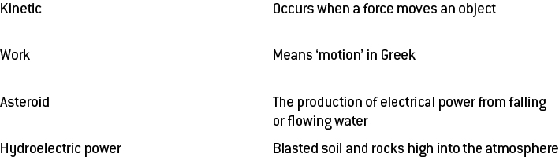

Literacy support worksheet

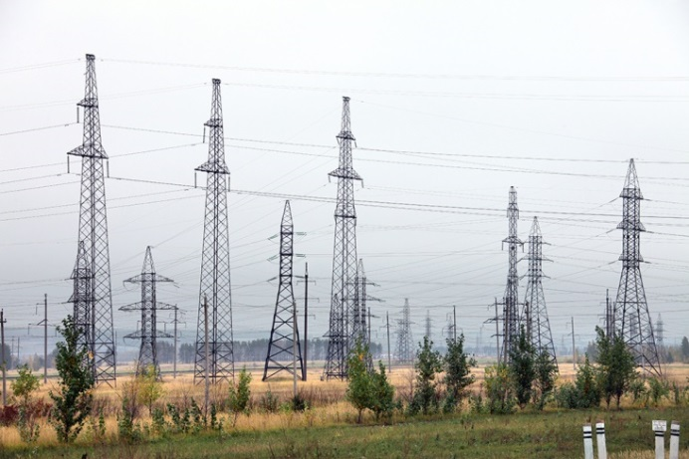3.4 Energy can be transformed

Pages 48-49 and 171

Energy transformations

1 Name a device that will convert:

a chemical to electrical energy:

b chemical into heat energy:

c electricity to light:

d chemical energy into sound:

e electricity to heat:

f potential to kinetic energy:

g chemical energy to light:

h kinetic energy to sound:

2 Draw a flow diagram (the first has been done for you) that shows all of the energy changes when:

a a light turns on

Chemical potential energy (coal) 🡪 Electrical 🡪 Light

b a toaster cooks your toast

c a church bell is struck by a bell-ringer

d a firework explodes

3 Why does a mug of hot chocolate eventually cool down? Where does the heat energy go?

4 What will happen to a glass of ice-cold water if left at room temperature?

5 Does hot chocolate or cool lemonade have more thermal energy? Explain your answer

6 Which of the drinks in question 6 will have more thermal energy if they are left on the same bench overnight?

7 Draw a diagram of the energy conversion when using a microwave oven.

|  |
| --- |
|  |

Word discovery

8 True or false

Read each statement below and circle whether it is true or false.

a Energy constantly changes from one form to another. T or F

b Clouds are as light as a feather. T or F

c Burning coal releases chemical energy. T or F

d Heat is the transfer of energy from a lower to a higher temperature. T or F

e As coffee cools the kinetic energy in its particles increase. T or F

f Thermal energy is the same as kinetic energy. T or F

g Vibrations are sound energy. T or F

Literacy support worksheet

3.5 Energy cannot be created or destroyed

Pages 50–51 and 172

Energy efficiency

1 What is energy efficiency?

2 What is the law of conservation of energy?

3 Energy conversions are not 100% efficient. Why not?

4 If a light globe was 100% energy efficient, what would it do?

5 Complete the table below to compare the efficiency of the three different types of light globes shown:

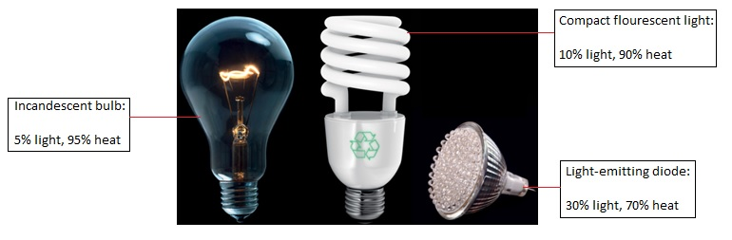

|  |  |  |  |
| --- | --- | --- | --- |
|  | Incandescent bulb | Compact fluorescent light | Light-emitting diode |
| % Light conversion |  |  |  |
| % Heat conversion |  |  |  |

6 Which of these three bulbs is the most energy efficient? Why?

7 Using the equation for energy efficiency, calculate the efficiency of each of the light bulbs. The first one has been done for you:

a Incandescent bulb: Energy efficiency = $\frac{5}{100}$ x 100 = 5%

b

c

8 Does your answer for question 5 match the calculations you completed in question 7? Why or why not?

9 Name two energy transformations that result in energy being wasted as heat and/or sound.

Word detective

10 Word search

Find the words listed, in the puzzle below.

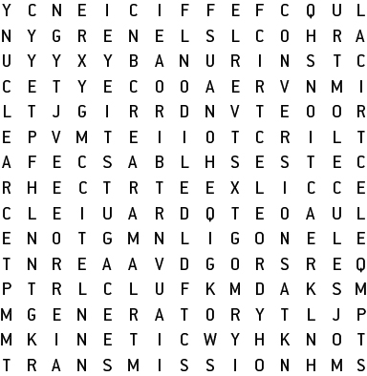

CHEMICAL

CONVERSIONS

EFFICIENCY

ELECTRICAL

ELECTRONS

ENERGY

FLUORESCENT

GENERATOR

HYDROELECTRIC

INCANDESCENT

KINETIC

MOLECULES

NUCLEAR

RADIATION

REACTIONS

SOLAR

THERMAL

TRANSMISSION

TURBINE

VOLTAGE

Literacy support worksheet

3.6 Energy efficiency can reduce energy consumption

Pages 52–53 and 173

Minimising energy consumption

1 A hair dryer has a fan and a heating element. How does each one work?

a Fan:

b Heating element:

2 Many people try to reduce the amount of energy they use in their homes. How does this help us? State two reasons.

3 Name four devices that heat either your home or your food:

4 The following graph shows the overall energy consumption used in your household over the course of 24 hours, from midnight to midnight.

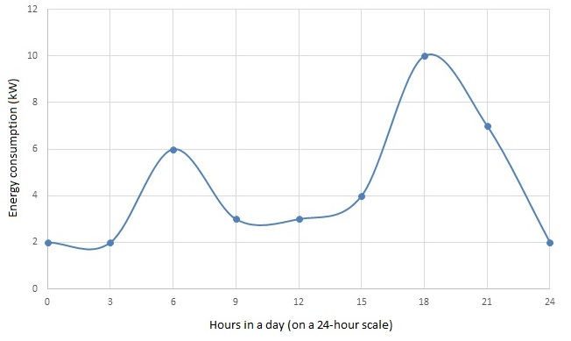

The spikes in energy consumption are at 6am and 6pm. Why do you think this happens?

5 Every room in the house below uses energy in different ways. State one way energy use could be reduced in each each room. E.g. Dining room- turn the heater off when not in use.

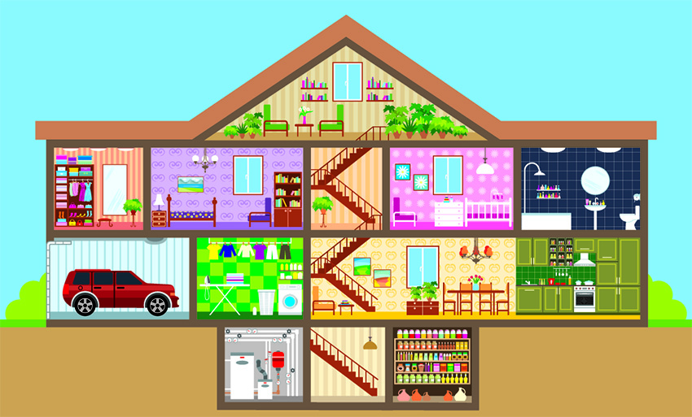

a Bedroom 1

b Bathroom

c Garage

d Dining room

e Kitchen

Word detective

6 Boggle

Find and circle as many words as you can in the puzzle below.

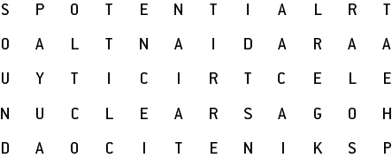

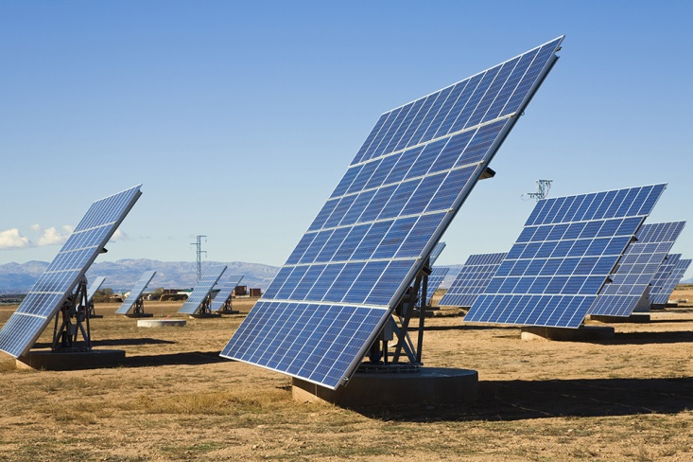Literacy support worksheet

3.7 Solar cells transform the Sun’s light energy into electrical energy

Pages 54–55 and 174

Solar energy

1 What is a solar cell?

2 Look at the graph on page 54 of *Oxford Science 8 Western Australian Curriculum*. At what time is the solar energy producing the highest irradiance?

3 Which three states produce the largest amount of solar energy?

4 Why do you think these states produce the largest amount of solar energy?

5 Why were solar cells invented?

6 Fill in the flow diagram showing how solar cells (photovoltaic cells) capture light energy:

a

b

c

7 How energy efficient are photovoltaic cells?

8 Why can solar cars only carry one person?

9 Why are solar cars not a practical method of transport?

10 In space, light travels at the speed of light (299 792 458 metres per second). There is a distance of 149 597 870 700 metres between the Earth and the Sun.

$$time= \frac{distance}{speed}$$

Use the equation above to calculate how many seconds it would take for the Sun’s light to reach Earth:

11 Convert this time into minutes by dividing by 60.

Word detective

12 Draw and label

Draw and label a solar panel with photovoltaic cells using the words below. Include how it generates electricity.

Light Electrons Semiconductor Flow

Literacy support worksheet

3.8 Engineers use their understanding of energy to solve problems

Pages 56–57 and 175-176

Engineering

1 What do each of the following engineers do?. Explain briefly.

a Chemical engineer

b Mechanical engineer

c Electrical engineer

d Civil engineer

2 For each of the tasks below, state which type of engineer would perform this job.

a Build a bridge:

b Build a satelite for NASA:

c Design and test robotics:

d Build the longest waterslide in the world:

e Design and build a car to be raced at NASCAR:

f Design shatter-proof glass:

g Build the tallest building in the world:

h Make a new type of biodegradable plastic:

i Design new medical equipment:

j Design a different type of paper:

k Organise the electronics of the CERN super-collider:

l Dig and reinforce a tunnel between Victoria and Tasmania:

3 Match each type of engineering assessment (on the left) with the question it asks:

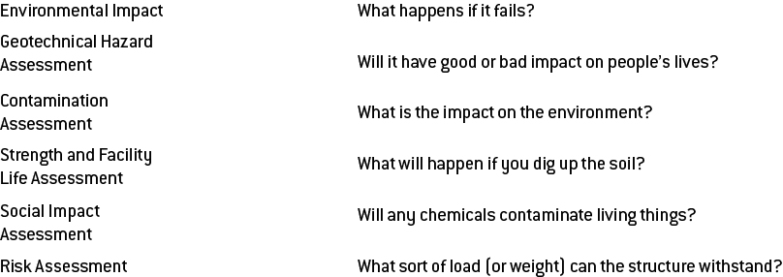

4 Your best friend develops an engineering proposal to place a waterslide in your house so that it will be easier to get drinks and icy poles on hot days, and so that summer will be awesome!

The waterslide is planned to go from the kitchen at the front, through the house, and then out to the backyard.

As the engineering expert, judge your friend’s proposal and think about the dangers of:

a Environmental impact (i.e. the impact on the rest of the house if the waterslide runs through the house)

b Social impact (i.e. will the family be happy?)

c Risks

d Possible contamination

e Strength and facility assessment

f Geotechnical hazards (maybe not with soil but definitely with the floors)

Word detective

5 Draw and label

Draw and label a diagram of the waterslide including the words from a to f, above. Explain how each one would work or not.

|  |
| --- |
|  |

Should the project go ahead? Why or Why not?